UNM GA Miss Valdosta Preliminary
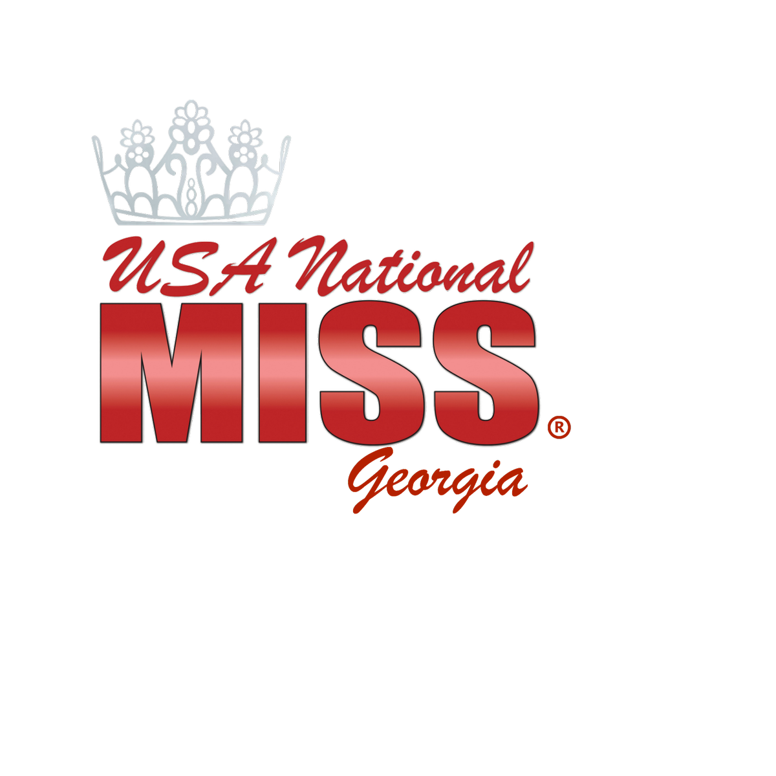
Sunday, April 25th Valdosta’s Performing Arts Center
3101 N. Forest Street Valdosta, GA 31602
Registration: 10:00am-11:00am
Interviews Junior Princess-Miss 11:00am
Pageant will begin at 2:00pm
*****************************************************************************
Age Divisions:
Baby Miss Ages 0-1 Years Old
Teeny Miss Ages 2-3
Junior Princess Ages 4-6
Princess Ages 7-9
Pre-Teen Ages 10-12
Junior Teen Ages 13-15
Teen Miss Ages 16-19
Miss Ages 20-25
*****************************************************************************
ENTRY FEE BREAKDOWN: OPTIONAL CATEGORIES:

UNM GA Miss Valdosta: $85.00 Most Photogenic: $10.00
(Ages 0-3) Beauty and Fun Fashion Most Beautiful: $10.00
Most Personality: $10.00

UNM GA Miss Valdosta: $125.00 Most Photogenic: $10.00
Beauty, Fun Fashion & Interview (Ages 4-up) Most Beautiful: $10.00
Best Personality: $10.00

UNM GA Miss Valdosta Sweetheart: $100 Most Photogenic: $10.00
Beauty, Fun Fashion & Interview (Ages 4-up) Most Beautiful: $10.00
This title not a bridge title! Best Personality: $10.00

Admission: $10.00 Ages 5 and Up

Prizes Include:
- Each QUEEN will receive a Crown, Embroidered Sash and Trophy!
- UNM GA Miss Valdosta Queens (Ages 4-up) will receive an Official UNM Preliminary Crown, Embroidered Sash, Trophy and their Entry Fee paid to UNM GA State 2022!
- All Division Runners Up and Optional Winners will receive a trophy!
- Each contestant will receive a Trophy!
- Ages 0-6 will also receive a Crown!
- Overall Miss Spirit of Valdosta is the Contestant who raises the most money above the Entry Fee through Sponsors. This Queen will receive a full round crown, embroidered sash, 4ft trophy and prizes!

PLEASE TYPE OR PRINT** CATEGORY _____________

Ages 4-25…Please bring 4 Copies to Registration

Please check one! UNM PRELIM _____
SWEETHEART _____

Contestant's Name ________________________________________________________

Sponsors: ______________________________________________________________

Cell Phone ________________________________________________
Email Address ___________________ @ ______________________________________
Age: ___________ Birthday ________________________________________________
School/Work: ____________________________________________________

In my spare time, I enjoy: __________________________________________
_________________________________________________________________

Special awards or recognitions earned: _______________________________
_________________________________________________________________

Clubs/Organizations: ______________________________________________

Hero/Role Model: _________________________________________________

Goals/Aspirations: ________________________________________________

Fun Fact About Me: _______________________________________________

Community service involvement: ____________________________________
_________________________________________________________________

Why should I be Crowned? __________________________________________
__________________________________________________________________

Favorite TV/Movie: _________________ Favorite Book: ____________
Favorite Disney Character: _________________________

DEADLINE TO ENTER!
Entry fee must be paid, and application submitted by April 18th!

Rules and Guidelines:
- Contestants 0-3 may wear a Long or Short Dress
- Contestants 4 –Up must wear a long gown.
- Fun Fashion…Let the contestant’s personality shine!
- Interview must be Sunday Dress or Interview Attire. Interview will be 2 Minutes in Length, and will be recorded for parents to receive within seven days from the pageant.
- Comments will be emailed or texted within one week!
For further information please contact:
229-269-8404 or email: USAnmgeorgia@gmail.com

UNM GA Miss Valdosta (0-3) $85.00 _____
DIVISION PHOTOGENIC $10.00 _____
Additional Photos $ 5.00 _____
Division MOST BEAUTIFUL $10.00 _____
Division BEST PERSONALITY $10.00 _____

UNM GA Miss Valdosta (4-25) $125.00 _____
DIVISION PHOTOGENIC $10.00 _____
Additional Photos $ 5.00 _____
Division MOST BEAUTIFUL $10.00 _____
Division BEST PERSONALITY $10.00 _____

UNM GA Miss Valdosta Sweetheart (0-25) $100.00 _____
(This title does not proceed to the UNM GA Pageant,
and be used for practice purposes only)
DIVISION PHOTOGENIC $10.00 _____
Additional Photos $5.00 ______
Division MOST BEAUTIFUL $10.00 _____
Division BEST PERSONALITY $10.00 _____

UNM GA MISS Valosta Supreme (0-3) $125.00 ____
Includes:
Division Photogenic
Division Most Beautiful
Division Best Personality
Winner will be the contestant who scores the highest in Ages 0-3!

UNM GA Miss Valdosta Supreme (4-9) $150.00 ____
Includes:
Division Photogenic
Division Most Beautiful
Division Best Personality
Winner will be the contestant who scores the highest in Ages 4-9!

UNM GA Miss Valdosta Supreme (10-15) $150.00 ____
Includes:
Division Photogenic
Division Most Beautiful
Division Best Personality
Winner will be the contestant who scores the highest in Ages 10-15!

UNM GA Miss Valdosta Supreme (16-25) $150.00 ____
Includes:
Division Photogenic
Division Most Beautiful
Division Best Personality
Winner will be the contestant who scores the highest in Ages 16-25!

Checks Made Payable to: AMT USA NATIONAL MISS GA or
Venmo @amanda-kirk-AMT
1921 Gornto Road #14 Valdosta, GA 31602

